W/C: 6/07/2020 Learning Project - TRANSITION
Age Range: EYFS
This week’s learning project focuses on supporting your child with transitioning to their new class.
It will give them the opportunity to reflect on their time in their current class, discuss their favourite memories and achievements whilst also considering their hopes and dreams for the next academic year.
Transition Activities
Days of the week | English activities | Phonics
Monday  MEMORIES | Monday- Talk to your child about their first day at school can they write a list of top tips for the next Foundation Stage telling them what to expect. Things like having their own coat peg, a place for their book bag. Where to put their water bottle. Who their teachers will be etc. etc. You can either draw or write your tips. | Phonics  Time to assess, flash cards of phonemes already learnt and any unsure of access Forest Phonics and work on the you’re your child is finding tricky. http://www.ictgames.com/mobilePage/forestPhonics/index.html
Tuesday  I’m looking forward to  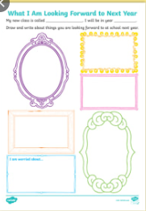 | Tuesday- Talk about moving to year 1 and what they are looking forward to. Write or draw a picture of what they want to know and find out | Write these words and put them into some sentences. Check you have lead in lines, finger spaces and use correct spellings.  Fox Shop Van ring tail moon road light park coin
Wednesday  All about me  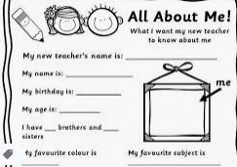 | Wednesday- Your new teacher is very excited to see and meet you. Can you create an ‘All about me fact file’ for your new teacher Miss Howarth. What is your favourite colour, food? Have you got any brothers or sisters? Who is in your family? What is your favourite story? Post them to Miss Howarth at school so she can read them before you start. | Read and write these words and put them into sentences Check you have lead in lines, finger spaces and use correct spellings.  box rich goat tear owl ship teeth zip Rain flight
Thursday  Storytime  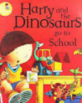 | Thursday- Read Harry and the dinosaurs go to school https://www.youtube.com/watch?v=gCR42DG1joU Talk about Harrys feelings throughout the day. Did you feel the same? Write and draw a picture from the story. | Read and write these tricky words and put them into sentences Check you have lead in lines, finger spaces and use correct spellings.  you they all are my all
Friday  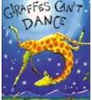 | Friday- Read or listen to the story ‘Giraffes Can’t Dance’ here. Talk about how Gerald the giraffe showed determination when trying to achieve his goals. Ask your child what they are looking forward to most about their new class, what they would like to get better at and what they would like to learn about.  Then discuss all of the things that will help your child get read for their new year group (see the list below). With your child, choose a few of the items from the list to practise over the next few weeks before September. | Read and write these words and put them into sentences Check you have lead in lines, finger spaces and use correct spellings.  he she me be was we

EYFS Transition Learning Project
Monday Maths | Tuesday Maths | Wednesday maths | Thursday maths | Friday maths
Write numbers 1 -20 making sure formations are correct | Doubling numbers  Choose a number count that many objects and double it. | Doubling butterflies  Draw a butterfly and fold in half. Paint a set ie 5 dots on one side then fold onto clear half to discover what the double is. Write the sum on a wing | Play a number game like snakes and ladders to practise one more and 1 less | Choose a number and do different movements. E.g. choose 5 and do 5 jumps  8 8 hops, 10 do 10 claps etc.
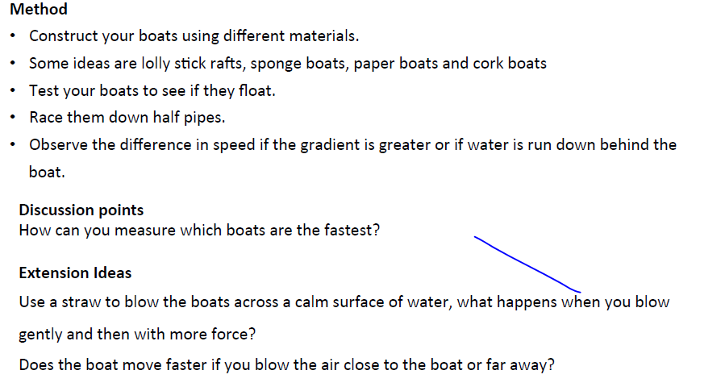
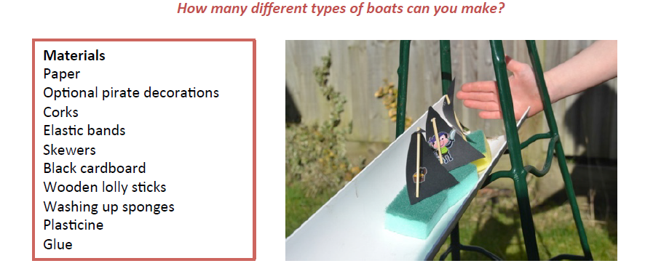
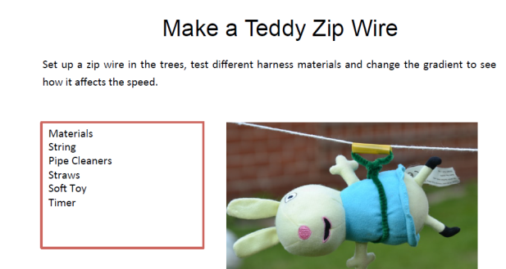
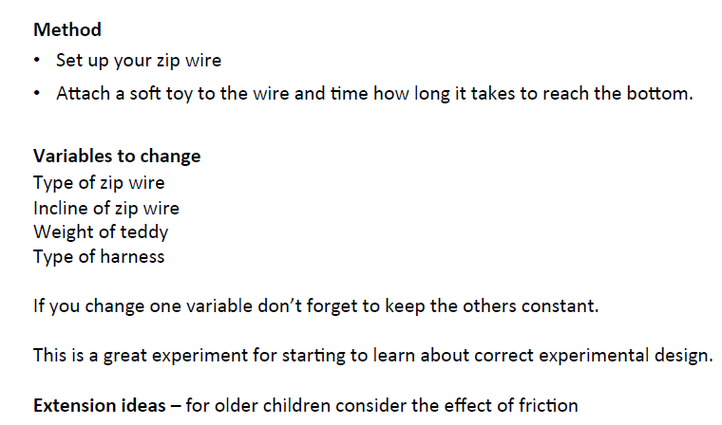
- Science theme afternoons

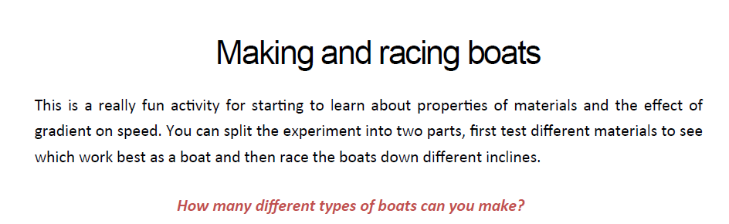
- Go outside and skim stones in the water
- Have a picnic
- Eat Ice cream
Additional Learning Resources Parents May Wish To Engage With:
- Tips and resources to support transition from Mentally Healthy Schools can be found here.
- Childline wants to help bring out the best in your child through some easy-to-do activities.
- The BBC Bitesize website has lots of helpful videos to support transition for both parents/carers and children.
- Parentkind provides handy hints to help prepare your child for their new class.
#TheLearningProjects
www.robinhoodMAT.co.uk

